**HCI**

**Baseline Knowledge**

* Principles of HCI
* Iterative, user-centred design
* Good practice in user interface design
* Guidelines, standards, interface paradigms
* Key evaluation techniques

**Design Principles and Guidelines**

**HCI VS Interaction Design**

HCI is concerned with the **design, evaluation and implementation** of interactive computing systems for human use and with the study of major phenomena surrounding them.

**Interaction Design**

The main difference between Interaction Design and HCI is one of scope. Interaction Design has cast its net much wider...HCI has traditionally had a narrower focus

**What are the *gulf of execution* and the *gulf of evaluation*?**

* **Gulf of execution –** a mismatch between the action a user has decided to undertake and the system’s apparent support for that action
* **Gulf of evaluation –** lack of feedback from a system that prevents a user from understanding whether or not an action has been successful.

**What is the Hawthorne effect?**

A term to describe potential differences in a participant’s behaviour under experimental conditions, due to the effect of knowingly being observed

**Functional and Non Functional Requirements**

**Functional requirements** define what the system or application will do - specifically in the context of an external interaction (with a user, or with another system).

* Visual
* Audio Language
* Navigation
* Buttons
* Social Network

**Non-functional requirements** are any requirements that don't describe the system's input/output behaviour.

* Response times - refresh

### Processing times – spinning icon

### Query and Reporting times – time to query database

### Throughput – Information being processed

### Storage – Space needed

**Storyboards**

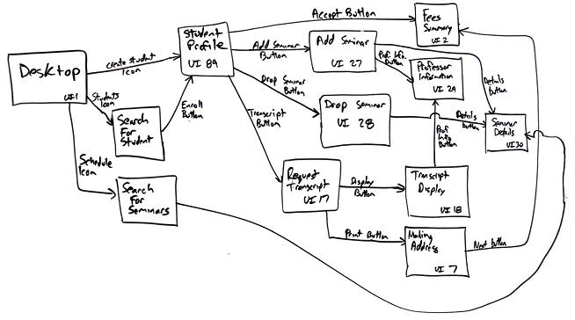

**Profiling Users**

**Cognitive Issues**:

* Memory, Visual, and Auditory, attention capacity

**Population issues**:

* Decision making, language comprehension disabilities

**Technology issues:**

* Computer graphics capabilities, connection speed, compatibility of systems

**Economic / logistic realities**:

* What is the cost of the system? Benefits outweigh costs.

**Geographical -** Location

**Demographical/socioeconomic -** Stereotypes

**Psychographic -** attributes values, lifestyles

**Behavioural**

**Involving Users**

Methods for involving users have evolved by:

* Recognition of diversity of systems, users and usage environment
* Recognition of move beyond focus on usability testing

User-centered design planning requires careful method **selection**, **scheduling** and **implementation**:

* For research, requirements establishment, design and evaluation

**User diversity:**

·       Physical appearance and shape.

·       Gender.

·       Life experience.

·       Social relationships.

·       Education.

·       Emotion, values, beliefs.

·       Capability (perceptual, cognitive, motor).

**Age-related capability change:**

·       Vision (visual acuity, colour perception, field of vision).

·       Hearing.

·       Motor skills (dexterity, sensitivity in fingers).

**Age-related *cognitive* capability change:**

·       Evidence of decline in *fluid* intelligence:

o    Processing, reasoning, and aptitude for learning.

o    Making inferences.

o    Prospective memory.

o    Selection, attention to clues.

o    Spatial cognition – patterns and relationships among obj.

Evidence that *crystallised* intelligence continues to increase or

remain stable into very late life – knowledge acquired through

education and experience.

Cognitive abilities also related to technology adoption – people with higher fluid intelligence more likely to use technology.

**Jared Spool’s 5 design approaches**

1. Unintended design
2. Self design
3. Genius design
4. Activity-focused design
5. User-focused design

**User modelling – Question 3**

**Static user models**

Once data is gathered not normally changed again, they are static.

**Dynamic user models**

Can be updated - takes the needs/ goals of the users into account.

**Stereotype based user models – based on demographic**

Make assumptions about a user even though there might be no data about that specific area, because demographic studies have shown that other users in this stereotype have the same characteristics.

**Highly adaptive user models**

Try to represent one particular user and therefore allow a very high adaptively of the system. In contrast to stereotype based user models they do not rely on demographic statistics but aim to find a specific solution for each user. Although users can take great benefit from this high adaptively, this kind of model needs to gather a lot of information first.

**Accessibility requirements**

* Usability Diagram
* Inclusive Design

**Participatory design - designing with users**

**Users as co-designers -** Rather than subjects of study

To better understand how to improve workplace

**Inclusive Design – Universal Design - 7 Principal**

1. **Equitable Use -** Design is useful and marketable to people with diverse abilities.
2. **Flexibility in Use -** Accommodates wide range of individual preferences and abilities.
3. **Simple and Intuitive Use -** design is easy to understand, regardless of the user’s experience, knowledge, language skills, or current concentration level.
4. **Perceptible Information -** The design communicates necessary information effectively to the user, regardless of ambient conditions or the user’s sensory abilities.
5. **Tolerance for Error -** The design minimizes hazards and the adverse consequences of accidental or unintended actions.
6. **Low Physical Effort -** The design can be used efficiently and comfortably and with a minimum of fatigue.
7. **Size and Space for Approach and Use -** Appropriate size and space is provided for approach, reach, manipulation, and use regardless of user’s body size, posture, or mobility.

**User Profiling**

**Layers of Complexity - *ISO 9241:210***

ISO Identifies 4 key activities in human-centred design

* Understand and specify **context of use**
* specify the user and organisational **requirements**
* produce candidate **design solutions**
* **Evaluate designs** against requirements.
* **Identify issues** with current experience
* **Evaluate** user experience
* Identify **requirements**
* **Prototype**
* **Evaluate** if requirements have been met

**User Centred Design**

* Motivation vs. persuasion
* Fear factor to confident user
* Learning methods – notes, games and peers
* Attitude to accessibility
* Diversity and life experience

**Usability:**

**Context of use**– *Intended users, usage environment, & Devices*

**Functionality** – U*nderstanding the tasks it is intended to support:*

**Other Stakeholders** – *Who else has an interest in the system?*

**Usability** – What are the system’s goals? How does it meet them?

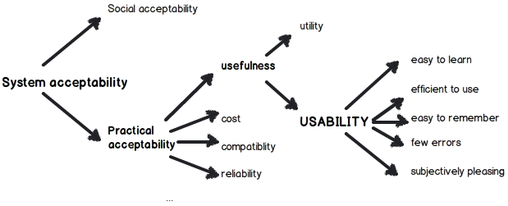Nielsen (1993) identified usability as a sub-category of usefulness:

**Cognitive complexity**

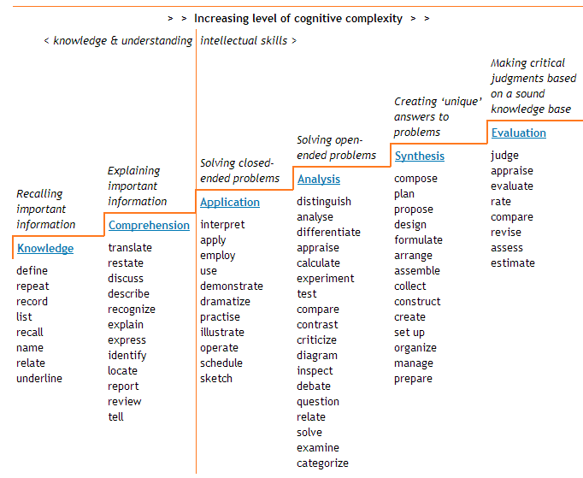

**Common characteristics of Elderly Users**

* Lifestyle Characteristics
* Sensory and cognitive changes
* Mobility and illness

**Research Methods of Elderly Users**

**Experimental** – Bringing a companion and involving them

**Cognitive testing** - Memory, Hearing , Techniques to remember

**Self Reporting** – Harder for inexperienced users

**Thinking Aloud** – Works well but subject to other factors

**User Dairies** – Difficult to complete worksheets whilst doing Tasks

**Timing** – Has to be adjusted to take account of other factors

**User Behaviour**

Understanding, profiling, predicting user behaviour, and capability on the impact on system design.

* User modelling; user diversity, human behaviour

**User groups**

* Characteristics
* Factors for appropriate interfaces and interaction metaphors

**Barriers in communication**

* People lie
* Things get lost in translation
* People are human – forgetting things, merging things together, generalising...
* You may influence the answers you receive

**User Model**

A user model represents a collection of personal data associated with a specific user. Therefore, it is the basis for any adaptive changes to the system's behaviour.

There are different design patterns for user models, though often a mixture of them is used.

**Static user models**

* Most basic kinds of user models.
* Once main data is gathered not normally changed again, static. Shifts in users' preferences are not registered and no learning algorithms are used to alter the model.

**Dynamic user models**

Dynamic user models allow a more up to date representation of users. Changes in their interests, their learning progress or interactions with the system are noticed and influence the user models. The models can thus be updated and take the current needs and goals of the users into account.

**Stereotype based user models**

Stereotype based user models are based on [demographic statistics](http://en.wikipedia.org/wiki/Demographics). Based on the gathered information users are [classified](http://en.wikipedia.org/wiki/Classification_in_machine_learning) into common stereotypes. The system then adapts to this stereotype. The application therefore can make assumptions about a user even though there might be no data about that specific area, because demographic studies have shown that other users in this stereotype have the same characteristics. Thus, stereotype based user models mainly rely on statistics and do not take into account that personal attributes might not match the stereotype. However, they allow predictions about a user even if there is rather little information about him or her.

**Highly adaptive user models**

Highly adaptive user models try to represent one particular user and therefore allow a very high adaptivity of the system. In contrast to stereotype based user models they do not rely on demographic statistics but aim to find a specific solution for each user. Although users can take great benefit from this high adaptivity, this kind of model needs to gather a lot of information first.

**Research Methods**

**Techniques**

* Understanding Techniques
* Applying techniques - preparing and managing a project

**Research Methods**

Understanding the nature and purpose of different HCI research methods; ability to select and apply a method and analyse and use its results appropriately

Theory/practice to learn how/when to apply specific methods:

* Understanding system’s target users and usage environment
* Applying knowledge to design
* Involving users in design
* Evaluating prototypes
* Refining - prototypes into working systems

**Methods for descriptive research**

* Ethnography
* Focus groups
* Questionnaires
* Surveys
* Prototyping
* Rip & mix
* Observation
* Interviews
* Dairies
* Case Studies
* Desk Research
* Log file or Help Desk Analysis

**Analysing descriptive research**

**Qualitative data: - Data that cannot be measured**

* Field notes
* Interview/questionnaire data
* Video and audio transcripts
* Published literature

**Analysis methods:**

* Do not assume a prior hypothesis
* Focus on discovering themes; developing theories
* Examples: grounded theory, thematic analysis

**Quantitative data – Data that can be measured**

**Evaluation to Prototypes**

Ability to turn knowledge generated by HCI research methods into prototypes for evaluation; entering the iterative design cycle

* Appreciating the value and limitation of “best practice” in interface and interaction design

**Usability Evaluation Principles – Jacob Neeson**

1. **Visibility of system status - Feedback**
2. **Match between system and the real world – Logical Order**
3. **User control and freedom – Emergency Exit**
4. **Consistency and standards – Conventions e.g. Symbols**
5. **Error prevention – Eliminate Error prone conditions**
6. **Recognition rather than recall**
7. **Flexibility and efficiency of use - Accelerators**
8. **Aesthetic and minimalist design**
9. **Help users recognize, diagnose, and recover from errors**
10. **Help and documentation**

**Evaluation Methods – Question 3**

**Formative** – Feedback on efforts made in the system

**Summative** – Comparing against existing standards

## Evaluation – Why do we evaluate?

We evaluate to assess the quality of a system, in order to:

* **Improve it**, level of **Quality Report**, & **Make Improvements**

In an iterative user-centred design, it allows us to:

* **Measure progress** & Identify **areas for improvement**

**Evaluation in UCD**

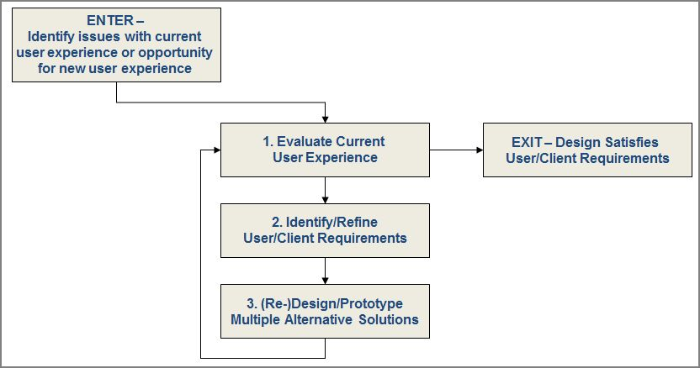

**Evaluation** – *What, When, Where, How*

**Evaluation - What we evaluate:**

* A completed, working system
* Lo-FI prototypes
* Beta versions
* Visual designs
* Workflows
* A single solution, or a comparison of alternatives

**Evaluation - When do we evaluate?**

* **Before we have made anything**

Evaluating other people’s work, Competitor analysis, & Usability evaluations

* **Once we have something to evaluate** – When we need

(**Formative**) feedback on efforts

(**Summative**) to benchmark against some form of standard

* As part of a formal evaluation plan, or simply opportunistic

**Evaluation - Where do we evaluate?**

Very dependent on what is being evaluated and the evaluation method used - *In the lab, field, other.*

**Framework for Evaluation – DECIDE**

* **Determine** the goals
* **Explore** the questions
* **Choose** the evaluation methods
* **Identify** the practical issues
* **Decide** how to deal with ethical issues
* **Evaluate**, analyse, interpret and present data

**Evaluation Methods**

**Three main types** *(Rogers, Sharp, Preece*)

* **Controlled settings involving users** – *lab, usability tests,*
* **Natural settings involving users** - Observation, interviews
* **Any settings not involving users -** Involving experts, simulations or models - Expert review, heuristic evaluation

**Methods of Evaluation - QHIOU**

* **Questionnaires**
* **Heuristic evaluation**
* **Interviews**
* **Observations**
* **Usability evaluation**
* **Ethnography**

**Questionnaires**

* **Fixed** **questions** Set
* **Widely distributed**; *some control over audience*
* Requires **careful design but** Fairly straightforward **Analysis**
* **Lacks flexibility** to gather explanations for answers
* Could be **misunderstood** or unanswered

**Interviews**

* Fixed or **semi-structured** set of **questions**
* More **flexible** than questionnaires
* **One-to-one -** Rich data - *intimidating for participant*
* Requires **time and effort**
* **Complex** data **analysis**

**Observation**

* **Watching** people OR asking **people** to **record usage** ( diary, logbook) OR **logging use** ( *system logs, analytics*)
* **Naturalistic** – *no control over participant*
* Potentially **rich, realistic data** - *Lots of data*
* Judgement to intervene when something interesting happens

**Usability evaluation**

* Formal **observation** of **users** carrying out  **pre-defined tasks**
* **Measurements** - *time taken, errors made, requests for help*.
* **User opinion** after use (perhaps before as well)
* **Controlled data** on areas of concern/interest
* How realistic is user performance? (Hawthorne effect)

**Heuristic evaluation**

* **‘Rules of thumb’** of a ‘good’ interface
* Heuristics to **walk through** an interface, noting potential problems
* Multiple evaluators independently evaluate, then compare results
* Needs appropriate heuristics - Android/iOS interface design docs
* Results comparison and agreeing output may take time

**Multiple method use allows for triangulation of data**

***Analysing and acting on data***

Turning evaluation data into meaningful information

* ***Identifying key issues*** *with an existing system*
* ***Prioritising fixes****: 5 point severity rating of usability issues;*

*0 (not a problem) <--> 4 (usability catastrophe)*

* ***Using evaluation data*** *to select one candidate* ***design solution***

***Multiple methods allow for triangulation***

* *Cross-checking and validation of findings from different methods*

**Social Implications**

Social implications of human-computer interaction design

* Adapting HCI methods for different environments and situations; dealing with constraints and opportunities
* Understanding the real world application of HCI methods in different domains

**Ethical considerations**

**Requirements for Exam**

* Describe, explain and apply an iterative, user-centred approach to systems design
* Select and apply appropriate research methods to establish a proposed system’s audience, activities, and usage context
* Apply awareness of the breadth and range of human needs and capabilities that need to be considered in system design
* Implement prototyping techniques to articulate design ideas influenced by research results
* Make informed design decisions, and be able to articulate and justify these decisions
* Evaluate existing and prototype systems against appropriate benchmarks
* Assess the potential and impact of emerging technologies and usage trends on effective user-centred design
* Balance creativity and innovation with usability and enjoyment